Code:
Python code: https://cornell.box.com/s/ov3nj2xtmcit36x28rqp6pznraam95mr

Results:

1. Coeff_Both_2021.xlsx:
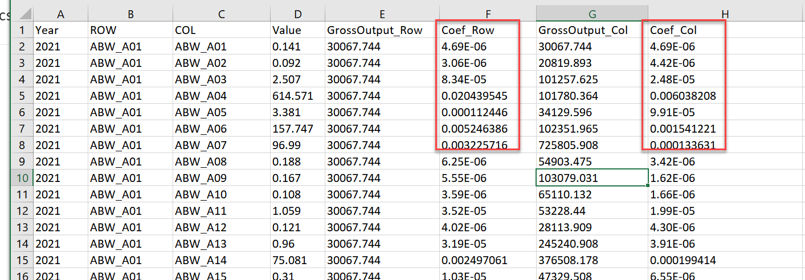
The Coef columns are calculated by:

      - This table is created based on the GrossOutput2021.csv and T_2021.csv datasets (described below)
      - The Value column shows the transaction from ROW to COL (basic prices; $1,000)
      - The GrossOutput_Row column shows the gross output of the “ROW” sector
      - The GrossOutput_COL column shows the gross output of the “COL” sector
      - The Coef_Row column is calculated as the ratio of Value/[gross output of the ROW sector]
      - The Coef_Row column is calculated as the ratio of Value/[gross output of the COL sector]
      - Collapsed imported inputs:
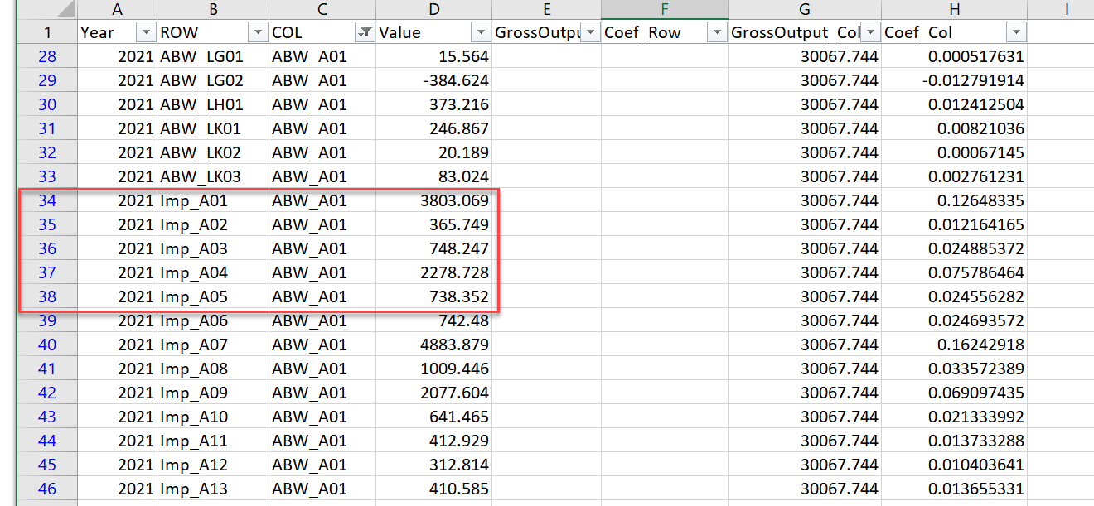

GrossOutput2021.csv:

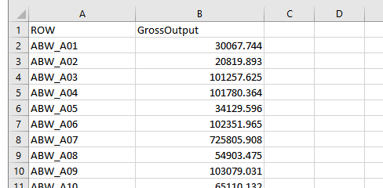
- The ROW column shows the Country_Sector, and the GrossOutput column shows the gross output of each sector.

T_2021.csv:
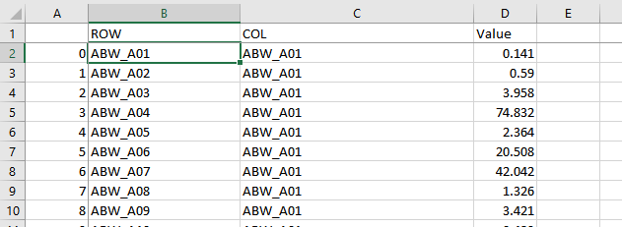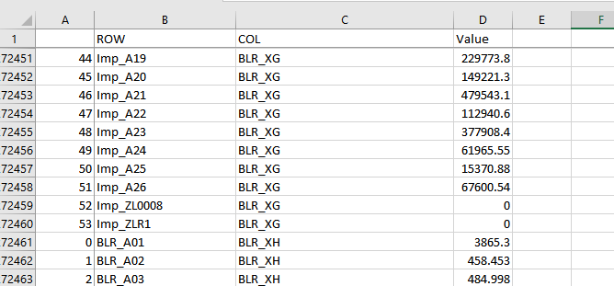
The ROW column indicates the supplier: Country_Sector
The COL column indicates the “consumer”: Country_Sector.
- The “consumer” is a sector if the letter is “_A”;
- it’s a final demand sector if it’s “_X”

